A000-Mex-Colima-Obsidian Blades-300 BCE-300 CE

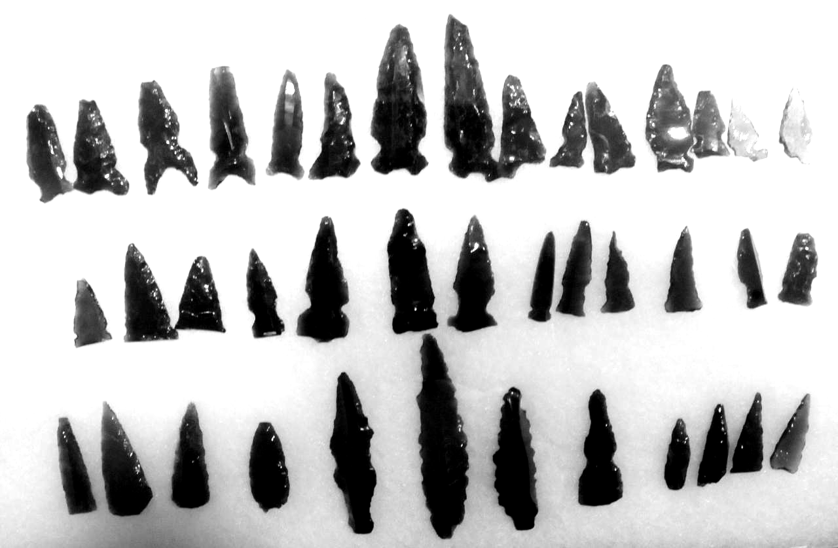

Fig. 1. 15 concave base and 13 straight base side notch projectile points and

12 lanceolate blades (including 2 heavily serrated, bottom row, center)

Case No.: 9

**Accession No.**

**Formal Label:** Mex-Colima-Obsidian Blades-300 BCE-300 CE

**Display Description:**

These obsidian points and blades were traded to villages in Colima beginning ca. 900 BCE during the Capacha Period and trade continued until the Late Tabachines Period (ca. 450 AD/CE) into villages in Colima from obsidian-bearing quarries in the central highlands of Jalisco and Michoacan (Beekman and Galvan 2006; nos. 1-5 and 6-12 in the map below).

**LC Classification:**

**Date or Time Horizon:**

**Geographical Area:**

**Map:**

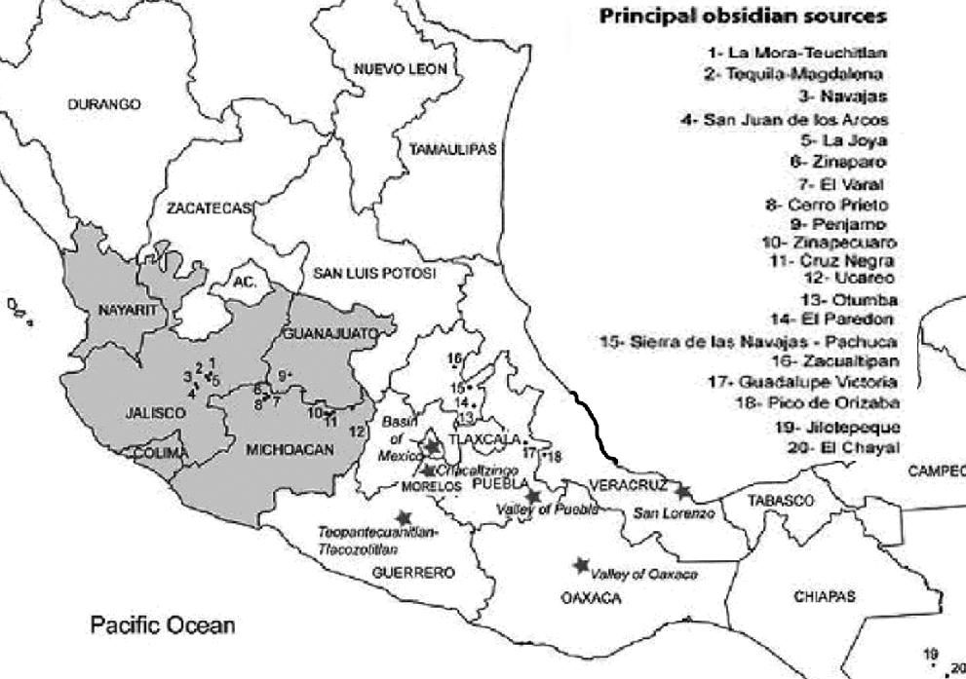

Fig.2. Location of principal obsidian quarries in Central and Southern Mexico. After Darras 2015

This long-distance trade and exchange of obsidian prismatic blades from craftsmen in Jalisco and Michoacan involved the preparation of obsidian cores close to the quarries. The cores were then transported to their village “customers” in Colima where the craftsman flaked and traded projectile points and blades for Colima products (Boksenbaum 1978; Boksenbaum et al. 1987). This spirit of entreprenurialism created a produducer and consumer market and a network of end–product dependence. Central Mexico, therefore, became the leader in pressure flake blade technology and the organization of itinerant production systems in long-distance networks. These blades are a result of this innovative spirit of invention and its concomitant economic system of trade and exchange.

**GPS coordinates:**

**Cultural Affiliation:**

**Medium: obsidian**

**Dimensions:**

**Weight:**

**Condition:**

**Provenance:**

**Discussion:**

**References:**

Beekman, Christopher, and Luis J. Galvan Villegas. 2006. “The shaft tomb of the Atemajac Valley

and their Relation to Settlement,” *Ancient Mesoamerica* 17(2):259–270.

Boksenbaum, Martín W. 1978. *Lithic Technology in the basin of Mexico during the Early and*

*Middle Pre-classic*. Unpublished Ph.D. dissertation, University of New York.

Boksenbaum, Martin W., Paul Tolstoy, Garman Harbottle, Jerome Kimberlin, and Mary Neivens.

1987. “Obsidian Industries and Cultural Evolution in the Basin of Mexico before 500 B.C.,”

*Journal of Field Archaeology* 14(1): 65–76.

Darras, Véronique. 2015. “Chapter 17. Development of Pressure Blade Technology

in North-Central and Western Mexico,” Fig. 17.1, p. 418. In P.M. Desrosiers (ed.), *The Emergence of Pressure Blade Making: From Origin to Modern Experimentation.* London: Springer Verlag*.*